1. Here json file holds array of two json documents.
2.   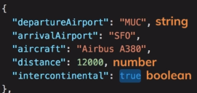
3. 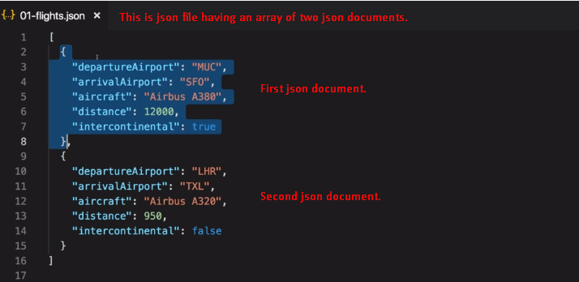 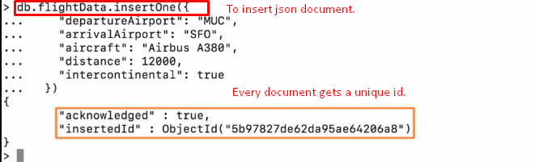  
   The type of unique id is **ObjectId** which is supported by mongodb.
4. 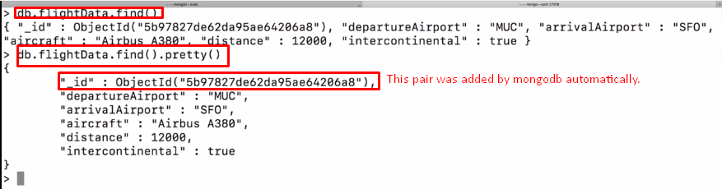
5. This **ObjectId** is data type supported by mongodb. This id is unique and can be used to sort documents as its value contains some timestamp.